SF ID: 104324

computer graphics

MINI PROJECT

L & T TECHNOLOGY and SERVICES

**LIST OF CONTENTS**

**S.No. CONTENTS PAGE NO.**

1. Problem statement 3
2. Description 3
3. Requirements gathering 5
4. Research 5
5. Test plan 6
6. Test cases 8
7. Expected results 8

**DOCUMENT HISTORY**

|  |  |  |  |  |  |
| --- | --- | --- | --- | --- | --- |
| REVISION  NUMBER | RELEASE  DATE | PREPARED  BY | REVIEWED  BY | APPROVED  BY | REMARKS  /REVISION  DETAILS |
| 1.0 | 25/09/2020 | S.D.N. Swarna Durga |  |  |  |
|  |  |  |  |  |  |
|  |  |  |  |  |  |

**PROBLEM STATEMENT:**

Modern trends in graphic design development are characterized by widespread transition from manmade graphics to digital technology. Rapidly developing of computer and information technology is resulting in increased physical correctness images, in active use of market-ready elements, component models, in increasing the functionality of software. The developers are trying to create computer programs as convenient, easier to learn, and their interfaces are characterized be term “humane”. In such circumstances there is a risk of images originality loss of projected objects, mostly through thoughtless use of ready “template” computer configurations that partly makes graphics unclear, low quality and devalues it. Creation of qualitative graphics requires the development and implementation of scientifically grounded principles, some of which are based on classical laws and experience of traditional man-made tools of image.

**DESCRIPTION:**

Computer graphics is the branch of [computer science](https://en.wikipedia.org/wiki/Computer_science) that deals with generating images with the aid of computers. Today, computer graphics is a core technology in digital photography, film, video games, cell phone and computer displays, and many specialized applications. A great deal of specialized hardware and software has been developed, with the displays of most devices being driven by [computer graphics hardware](https://en.wikipedia.org/wiki/Graphics_hardware). It is a vast and recently developed area of computer science. The phrase was coined in 1960 by computer graphics researchers Verne Hudson and William Fetter of Boeing. It is often abbreviated as CG, or typically in the context of film as [computer generated imagery](https://en.wikipedia.org/wiki/Computer-generated_imagery) (CGI).

Some topics in computer graphics include [user interface design](https://en.wikipedia.org/wiki/User_interface_design), [sprite graphics](https://en.wikipedia.org/wiki/Sprite_(graphics)), [rendering](https://en.wikipedia.org/wiki/Rendering_(computer_graphics)), [ray tracing](https://en.wikipedia.org/wiki/Ray_tracing_(graphics)), [geometry processing](https://en.wikipedia.org/wiki/Geometry_processing), [computer animation](https://en.wikipedia.org/wiki/Computer_animation), [vector graphics](https://en.wikipedia.org/wiki/Vector_graphics), [3D modeling](https://en.wikipedia.org/wiki/3D_modeling), [shaders](https://en.wikipedia.org/wiki/Shader), [GPU](https://en.wikipedia.org/wiki/GPU) design, [implicit surface](https://en.wikipedia.org/wiki/Implicit_surface) visualization, [image processing](https://en.wikipedia.org/wiki/Image_processing), [computational photography](https://en.wikipedia.org/wiki/Computational_photography), [scientific visualization](https://en.wikipedia.org/wiki/Scientific_visualization), [computational geometry](https://en.wikipedia.org/wiki/Computational_geometry) and [computer vision](https://en.wikipedia.org/wiki/Computer_vision), among others. The overall methodology depends heavily on the underlying sciences of [geometry](https://en.wikipedia.org/wiki/Geometry), [optics](https://en.wikipedia.org/wiki/Optics), [physics](https://en.wikipedia.org/wiki/Physics), and [perception](https://en.wikipedia.org/wiki/Perception).

Computer graphics is responsible for displaying art and image data effectively and meaningfully to the consumer. It is also used for processing image data received from the physical world, such as photo and video content. Computer graphics development has had a significant impact on many types of media and has revolutionized [animation](https://en.wikipedia.org/wiki/Animation), [movies](https://en.wikipedia.org/wiki/Movies), [advertising](https://en.wikipedia.org/wiki/Advertising), [video games](https://en.wikipedia.org/wiki/Video_game), and [graphic design](https://en.wikipedia.org/wiki/Graphic_design) in general.

|  |  |
| --- | --- |
| **FUNCTION** | **DESCRIPTION** |
| initgraph | It initialise the graphics system by loading the passed graphics driver then changing the system into graphics mode. |
| getmaxx | It returns the maximum X coordinate in current graphics mode and driver |
| setcolour | It changes the current drawing colour. Default colour is white. Each colour is assigned a number, like BLACK is 0 and RED is 4. Here we are using colour constants defined inside graphics.h header file. |
| setfillstyle | It sets the current fill pattern and fill colour |
| circle | It draws a circle with radius r and centre at (x,y) |
| floodfill | It is used to fill a closed area with current fill pattern and fill colour. It takes any point inside closed area and colour of the boundary as input. |
| cleardevice | It clears the screen, and sets current position to (0,0) |
| kbhit | It is used to determine whether a key is pressed or not. It returns a non-zero value if a key is pressed otherwise zero. |
| delay | It is used to suspend execution of a program for a M milliseconds. |
| closegraph | It unloads the graphics drivers and sets the screen back to text mode. |

**REQUIREMENTS GATHERING:**

**SOFTWARE REQUIREMENTS:**

* Operating system : Windows
* Application software : Turbo C/C++
* Language : C (computer graphics)

**HARDWARE REQUIREMENTS:**

* Hard disk : 32 GB
* Memory : 4 MB
* Processor : Any Pentium version
* File size : 90 MB

**RESEARCH:**

Computer graphics is an art of drawing pictures, lines, charts, etc using computers with the help of programming. Computer graphics is made up of number of pixels. Computer graphics deals with the study of technology and techniques for generating and displaying images of natural and synthetic objects. It is an exciting field with a wide range of applications including entertainment, graphical user interfaces, industrial modelling, molecular modelling, surgery planning, virtual reality.

Today, computer graphics is widespread. Such imagery is found in and on television, newspapers, weather reports, and in a variety of medical investigations and surgical procedures. A well-constructed [graph](https://en.wikipedia.org/wiki/Chart) can present complex statistics in a form that is easier to understand and interpret. In the media "such graphs are used to illustrate papers, reports, theses", and other presentation material.

Many tools have been developed to visualize data. Computer generated imagery can be categorized into several different types:

1. Two dimensional (2D)
2. Three dimensional (3D) and
3. Animated graphics.

As technology has improved, [3D computer graphics](https://en.wikipedia.org/wiki/3D_computer_graphics) have become more common, but [2D computer graphics](https://en.wikipedia.org/wiki/2D_computer_graphics) are still widely used. Computer graphics has emerged as a sub-field of [computer science](https://en.wikipedia.org/wiki/Computer_science) which studies methods for digitally synthesizing and manipulating visual content. Over the past decade, other specialized fields have been developed like [information visualization](https://en.wikipedia.org/wiki/Information_visualization), and [scientific visualization](https://en.wikipedia.org/wiki/Scientific_visualization) more concerned with "the visualization of [three dimensional](https://en.wikipedia.org/wiki/Three-dimensional_space) phenomena (architectural, meteorological, medical, [biological](https://en.wikipedia.org/wiki/Biological_Data_Visualization), etc.), where the emphasis is on realistic renderings of volumes, surfaces, illumination sources, and so forth, perhaps with a dynamic (time) component".

**TEST PLAN:**

**Introduction :**

This project is a computer graphics based. A ball is to move left, Right, up and down using the arrow keys. By using this method we can also design a game.

Features to be tested:

In this project the features to be tested is whether the ball is in circle shape and movement is done according to the arrow direction.

**Approach :**

1. Run the program if any errors occurs check for it and again run the program.
2. After running is done successfully ball will appear on the screen.
3. Use any arrow key to move the ball.
4. Press esc to exit from the window.

* Must examine the entire screen and not just a small part of it.
* Move the ball with all the arrow keys and closely examine the effect.
* Test for platform compatibility.

**Unit testing :**

In unit testing the inputs and outputs will be given by us so that the system will check the result and notify whether the unit is passed or not.

**BEHAVIORAL DIAGRAM:**

Execute the code

Yes No

Display the ball on screen

Check errors

Operate the ball with arrow keys

Press esc /enter

**TEST CASES :**

|  |  |  |
| --- | --- | --- |
|  | **INPUTS** | **RESULT** |
| 1 | Press left arrow key | Ball should move left |
| 2 | Press right arrow key | Ball should move right |
| 3 | Press up arrow key | Ball should move upwards |
| 4 | Press down arrow key | Ball should move downwards |

**EXPECTED RESULTS:**

In this project the main view is to move the ball according to the inputs we given to it using the arrow keys.

Ball should move left when the left arrow key is pressed. How many times user clicks the left arrow key that many times it should move only in specified boundaries.

Same result should get as mentioned above when we use any arrow key

The limitations of this project is the ball should be moved only in the boundary lines

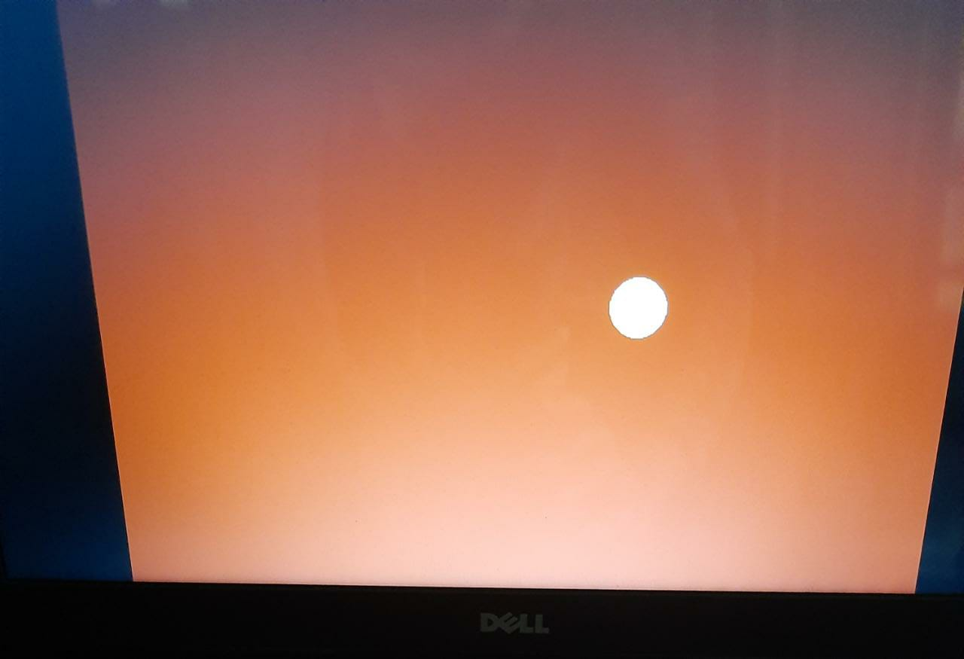

Figure: Appearance of yellow ball on the coloured screen.